MODERATE: Create a incident on insert of company/individual

Company
If Type=”Customer”, create a sales incident for this company
If Customer.subType = “Large Account”, set priority to “Immediate”, else “Medium”
Default values for all other properties

Individual
If Type=”Customer” and Source=”Referral”, create a sales incident for this company
If Customer.subType = “Large Account”, set priority to “Immediate”, else “Medium”
Default values for all other properties

- Add this step to OED on individual.insert
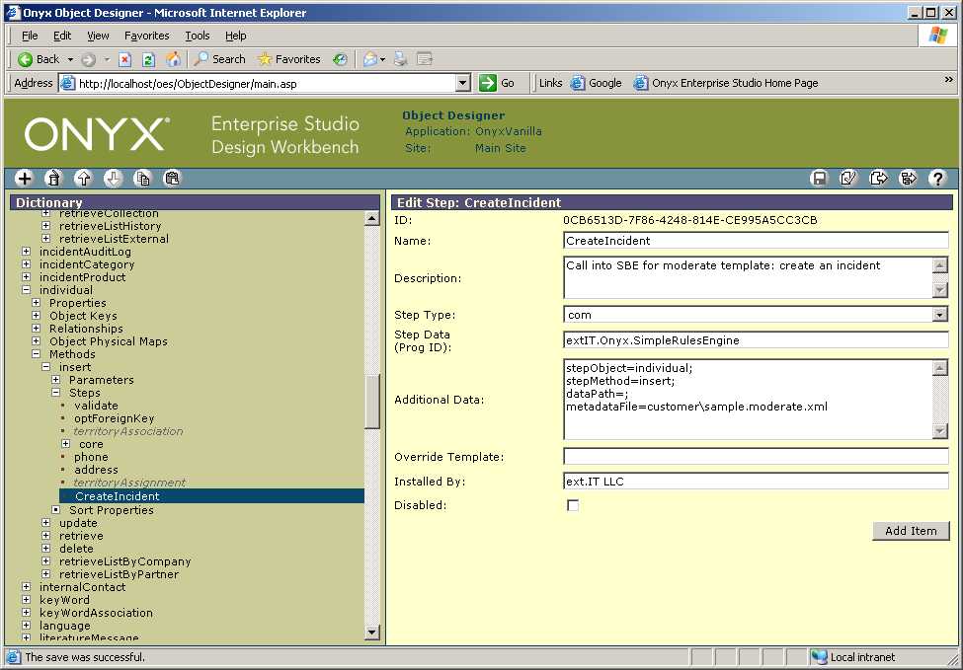

- Add this step to OED on company.insert

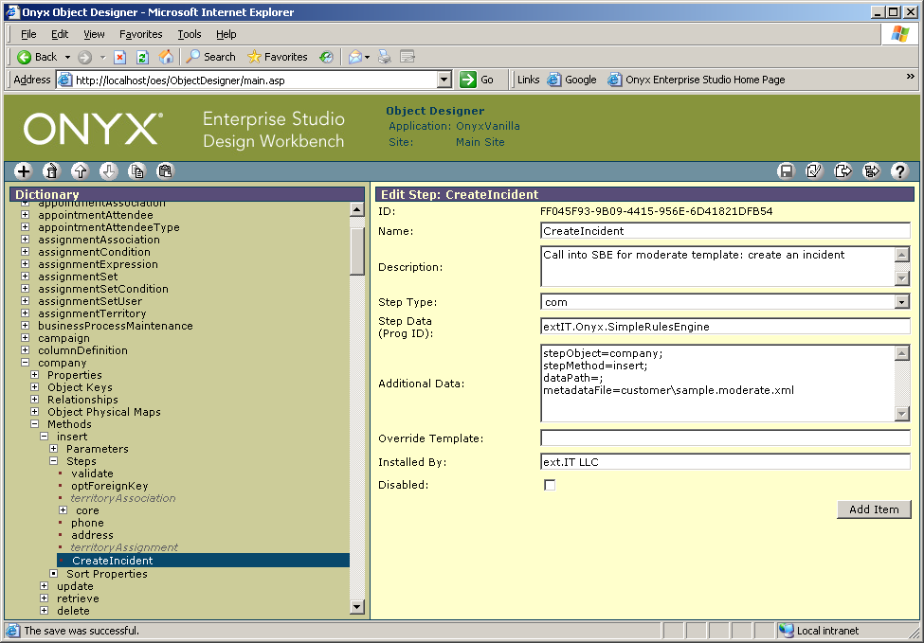

- Publish the OED
- Create directory c:\temp [for the log outputs defined in the metadata XML]
- Save file sample.moderate.xml in
C:\Program Files\Onyx\AppServer\Applications\Onyx\simpleRules\metadata\customer
- Run company and individual inserts in OEP
- Check for created sales incidents

File
C:\Program Files\Onyx\AppServer\Applications\Onyx\simpleRules\metadata\incident\sample.moderate.xml:
<rules description="sample.moderate.xml - On individual.insert and company.insert, create an incident">

<addNode description="create a node to store the input parameters for the incident in parameters/_helpers">
<path>
<literal>//parameters</literal>
</path>
<name>
<literal>_helpers</literal>
</name>
</addNode>
<objectInstance>
<path>
<literal>//parameters/_helpers</literal>
</path>
<name>
<literal>incident</literal>
</name>
</objectInstance>
<addNode description="create a node to store whetrher we want to create an incident based on the input properties">
<path>
<literal>//parameters/_helpers</literal>
</path>
<name>
<literal>_doCreateIncident</literal>
</name>
</addNode>
<setNodeValue>
<path>
<literal>//parameters/_helpers/_doCreateIncident</literal>
</path>
<value description="set default: 0 == NO">
<literal>0</literal>
</value>
</setNodeValue>

<saveXML mode="development" description="Log the input XML">
<name>
<literal>c:\temp\sample.moderate__INPUT.xml</literal>
</name>
<path>
<literal>/stepPackage</literal>
</path>
</saveXML>

<if description="COMPANY">
<test>
<and>
<exists description="Check result of insert">
<literal>//returnXml/methodStatus/statusType[.!='failure']</literal>
</exists>
<exists description="Check for company">
<literal>//returnXml/parametersReturn/company[@objectType='company']</literal>
</exists>
<exists description="Check for type=Customer">
<literal>//parameters/company/companyTypeCode[.='100325']</literal>
</exists>
</and>
</test>
<then>
<setNodeValue>
<path>
<literal>//parameters/_helpers/_doCreateIncident</literal>
</path>
<value description="set flag to YES, do create the incident">
<literal>1</literal>
</value>
</setNodeValue>
<setNodeValue>
<path>
<literal>//parameters/_helpers/incident/ownerId</literal>
</path>
<value>
<getNodeValue>
<literal>//returnXml/parametersReturn/company/primaryId</literal>
</getNodeValue>
</value>
</setNodeValue>
<setNodeValue>
<path>
<literal>//parameters/_helpers/incident/ownerType</literal>
</path>
<value>
<literal>2</literal>
</value>
</setNodeValue>
<if>
<test description="If this is a large account, set immediate priority">
<exists description="Check for subType=Large Account">
<literal>//parameters/company/companySubTypeCode[.='101280']</literal>
</exists>
</test>
<then>
<setNodeValue>
<path>
<literal>//parameters/_helpers/incident/priorityId</literal>
</path>
<value>
<literal>117</literal>
</value>
</setNodeValue>
</then>
<else description="Use medium priority">
<setNodeValue>
<path>
<literal>//parameters/_helpers/incident/priorityId</literal>
</path>
<value>
<literal>127</literal>
</value>
</setNodeValue>
</else>
</if>

</then>
</if>

<if description="INDIVIDUAL">
<test>
<and>
<exists description="Check result of insert">
<literal>//returnXml/methodStatus/statusType[.!='failure']</literal>
</exists>
<exists description="Check for individual">
<literal>//returnXml/parametersReturn/individual[@objectType='individual']</literal>
</exists>
<exists description="Check for type=Customer">
<literal>//parameters/individual/userTypeId[.='100325']</literal>
</exists>
<exists description="Check for source=Referral">
<literal>//parameters/individual/sourceId[.='337']</literal>
</exists>
</and>
</test>
<then>
<setNodeValue>
<path>
<literal>//parameters/_helpers/_doCreateIncident</literal>
</path>
<value description="set flag to YES, do create the incident">
<literal>1</literal>
</value>
</setNodeValue>
<setNodeValue>
<path>
<literal>//parameters/_helpers/incident/ownerId</literal>
</path>
<value>
<getNodeValue>
<literal>//returnXml/parametersReturn/individual/primaryId</literal>
</getNodeValue>
</value>
</setNodeValue>
<setNodeValue>
<path>
<literal>//parameters/_helpers/incident/ownerType</literal>
</path>
<value>
<literal>1</literal>
</value>
</setNodeValue>
<if>
<test description="If this is a large account, set immediate priority">
<exists description="Check for subType=Large Account">
<literal>//parameters/individual/userSubTypeId[.='101280']</literal>
</exists>
</test>
<then>
<setNodeValue>
<path>
<literal>//parameters/_helpers/incident/priorityId</literal>
</path>
<value>
<literal>117</literal>
</value>
</setNodeValue>
</then>
<else description="Use medium priority">
<setNodeValue>
<path>
<literal>//parameters/_helpers/incident/priorityId</literal>
</path>
<value>
<literal>127</literal>
</value>
</setNodeValue>
</else>
</if>

</then>
</if>

<if description="Fill the remaining incident fields if an incident should be created.">
<test>
<exists description="Check flag whether we should create an incident">
<literal>//parameters/_helpers/_doCreateIncident[.='1']</literal>
</exists>
</test>
<then>
<setNodeValue description="category: sales incident">
<path>
<literal>//parameters/_helpers/incident/categoryId</literal>
</path>
<value>
<literal>3</literal>
</value>
</setNodeValue>

<setNodeValue description="category: sales incident">
<path>
<literal>//parameters/_helpers/incident/typeId</literal>
</path>
<value>
<literal>3</literal>
</value>
</setNodeValue>

<setNodeValue description="Product: default">
<path>
<literal>//parameters/_helpers/incident/productId</literal>
</path>
<value>
<literal>salesProd</literal>
</value>
</setNodeValue>

<setNodeValue description="description1: Auto-created incident for Customer">
<path>
<literal>//parameters/_helpers/incident/description1</literal>
</path>
<value>
<literal>Auto-created incident for Customer</literal>
</value>
</setNodeValue>

<setNodeValue description="Source: Mail">
<path>
<literal>//parameters/_helpers/incident/sourceId</literal>
</path>
<value>
<literal>132</literal>
</value>
</setNodeValue>

<setNodeValue description="status: Open">
<path>
<literal>//parameters/_helpers/incident/statusId</literal>
</path>
<value>
<literal>130</literal>
</value>
</setNodeValue>

<setNodeValue description="assignedTo: sa">
<path>
<literal>//parameters/_helpers/incident/assignedTo</literal>
</path>
<value>
<literal>sa</literal>
</value>
</setNodeValue>

<saveXML mode="development" description="Log the incident.insert input XML">
<name>
<literal>c:\temp\sample.moderate__incident.insert.xml</literal>
</name>
<path>
<literal>/stepPackage</literal>
</path>
</saveXML>

<otmCall>
<object>
<literal>incident</literal>
</object>
<method>
<literal>insert</literal>
</method>
<inputParameters>
<addNode>
<path>
<literal>//parameters</literal>
</path>
<name>
<literal>incident</literal>
</name>
</addNode>
<fieldMap>
<source>
<literal>//parameters/_helpers/incident</literal>
</source>
<target>
<literal>incident</literal>
</target>
</fieldMap>
<saveXML mode="development" description="Log OTM call contents to file">
<name>
<literal>c:\temp\otmCall.incident.insert.xml</literal>
</name>
<path>
<literal>.</literal>
</path>
<source>target</source>
</saveXML>
</inputParameters>
<outputParameters></outputParameters>
<onError>stop</onError>
</otmCall>

</then>
</if>

</rules>

